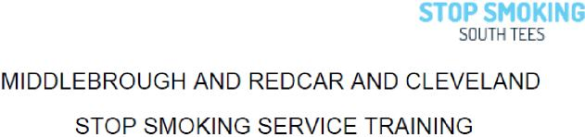
2021
The following training courses are available to health and community based staff who are
interested in delivering smoke free advice and support for people in the Middlesbrough, and Redcar & Cleveland areas.
Registration is via Eventbrite.co.uk.
Please email the service within 48hr to cancel if you are unable to attend
STOP SMOKING ANNUAL REFRESHER TRAINING FOR ADVISORS
Annual mandatory refresher training for all intermediate stop smoking advisors to maintain knowledge and skills, and keep updated with current guidance and products. Due to COVID-19 all training will be held remotely via Zoom
Thursday 10th June 2021 | 1pm to 3.00pm | This training will be held online Via Zoom  To register Book Here
Wednesday 30th June 2021 | 1pm to 3.00pm | This training will be held online Via Zoom  To register Book here

STOP SMOKING INTERMEDIATE ADVISOR TRAINING (Level 2 & 3)
This course and follow up support will enable participants to deliver level 2 & 3 stop smoking services, including support for pregnant women and young people. The sessions include supporting clients to quit smoking tobacco through the delivery of a 12 week programme, including assessment, access to appropriate stop smoking medication and ongoing behavioural support.
Prior to attending the session, delegates are requested to complete the NCSCT intermediate advisor
training. https://www.ncsct.co.uk/publication_training-and-assessment-programme.php
On completion of the session all delegates must attend a shadowing session(s) within 6 weeks and
complete competency training in practice. In order to deliver stop smoking support in community
This training will be held via Microsoft Teams. You must attend both days .To register book here
Book Here
Day 1 – 7th July , 9am-12pm
Day 2- 8th July 1pm -4pm

9am to 4pm
Inspire 2 Learn, Normanby, Middlesbrough

