YOUR FULL NAME & TITLE
ADDRESS
POSTCODE
Pharmacist Name
Address etc.
Dear [Pharmacist],
In the next few weeks the Darlington Adult service will be working with a new Case Management system called ILLY CarePath. From September 2023 all prescriptions for our OST (Opiate Substitute Treatment) clients will be generated from CarePath.
Prescriptions for OST medications such as Methadone and Buprenorphine will be dispensed using either FP10MDA (Blue) or FP10 (Green) forms – just as they have been before. However, there are key changes to the format of the scripts which I wish to highlight to you ahead of the change.
Below are example Physeptone / Methadone scripts, fig.1 has been produced by Nebula (our incumbent prescribing system) and fig.2 has been produced by CarePath (the system we’ll be using from February).
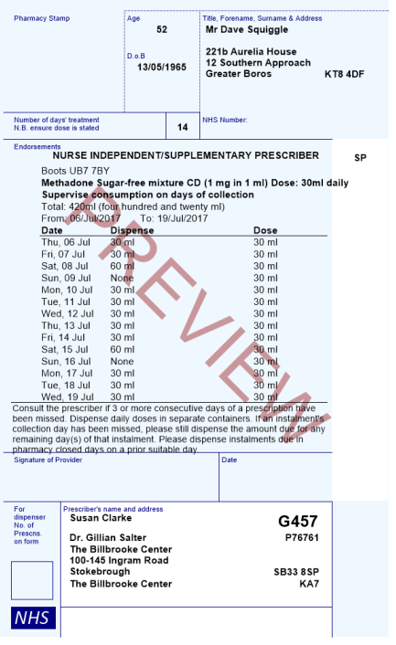
Please insert image of equivalent Nebula example script

Fig.2
Fig.1

Below are example Buprenorphine / Subutex scripts, fig.1 has been produced by Nebula and fig.2 has been produced by CarePath. The key difference between the two scripts is that CarePath has the capacity to print prescriptions for multiple-dose medications on one prescription.
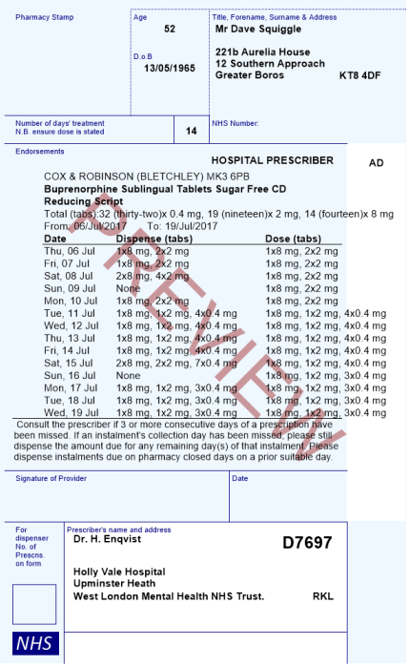
Please insert image of equivalent Nebula example script

Fig.2
Fig.1

If you have any questions about the changes to the format of printed prescriptions then please contact the XXXXXXX on XXXXXX.

Yours Sincerely,

XXXXXXX

